Marketing Funnel & Conversion Performance Analysis

Future Interns – Data Science & Analytics Task 3

Submitted By
Name: Santhi Priya

Project Overview
The objective of this project is to analyze marketing campaign performance using the Bank Marketing dataset. The analysis focuses on understanding customer conversion behavior, identifying high-performing marketing channels, and discovering areas where customer drop-off occurs in the marketing funnel.
The dashboard was developed in Power BI to present interactive visualizations and key performance indicators that help support business decision-making.

Dataset
Dataset Name: Bank Marketing Dataset (bank-additional-full.csv)
The dataset contains customer demographic information, campaign details, communication channels, previous marketing outcomes, and subscription results.

Tools Used
- Microsoft Power BI
- Microsoft Excel (Data Preparation)
- Bank Marketing Dataset

Objectives
- Analyze customer conversion performance.
- Measure conversion rates.
- Identify customer drop-off points.
- Compare campaign performance across different customer segments.
- Generate business recommendations based on data.

Dashboard Overview
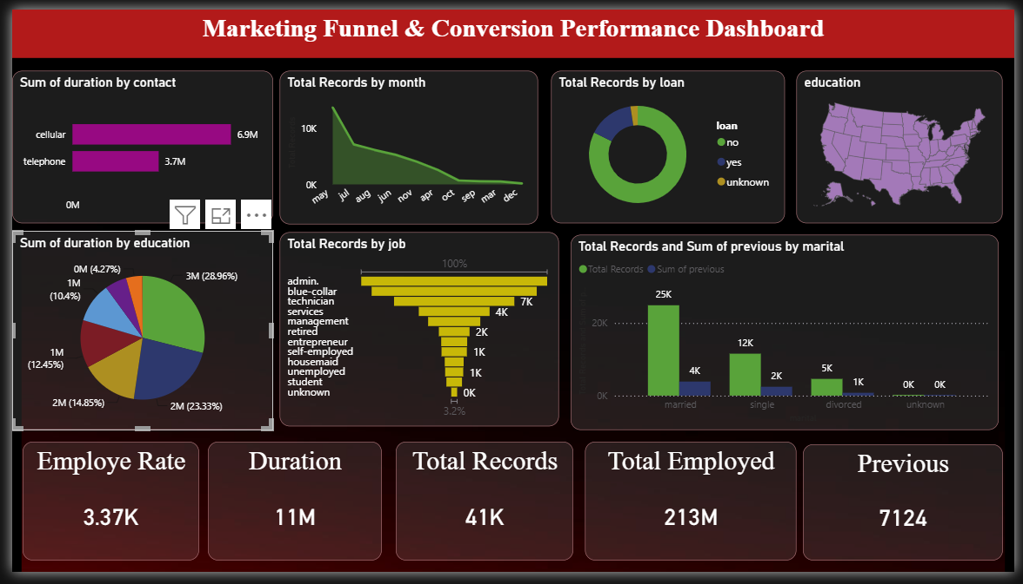

Dashboard Visualizations
The dashboard includes the following visualizations:
- KPI Cards
  - Total Customers
  - Converted Customers
  - Conversion Rate
- Funnel Analysis
- Conversion Distribution (Donut Chart)
- Job-wise Customer Analysis
- Contact Method Analysis
- Monthly Campaign Performance
- Education-wise Analysis
- Age Distribution
- Campaign Performance
- Previous Campaign Outcome
- Interactive Filters

Key Insights
- Most customers did not subscribe to the marketing campaign.
- Cellular contact performed better than telephone communication.
- Certain months recorded higher customer subscriptions.
- Some occupations showed better conversion rates than others.
- Previous successful campaign outcomes increased the likelihood of customer conversion.

Recommendations
- Focus marketing campaigns on high-converting customer segments.
- Increase campaigns during months with higher conversion rates.
- Improve communication strategies for customers who previously did not respond.
- Use personalized marketing campaigns based on customer demographics.
- Optimize follow-up campaigns using previous campaign results.

Conclusion
This project demonstrates how marketing data can be transformed into meaningful business insights using Power BI. The dashboard enables organizations to monitor marketing performance, evaluate conversion rates, identify customer behavior patterns, and make data-driven decisions to improve future campaigns.

